**Creating Microservices for account and loan**

**Objective:**

To create and run two independent Spring Boot microservices using “https://start.spring.io/”:

* AccountService – returns basic account details.
* LoanService – returns basic loan details.
* Include dependencies:

i)Spring Boot Dev Tools

ii)Spring Web

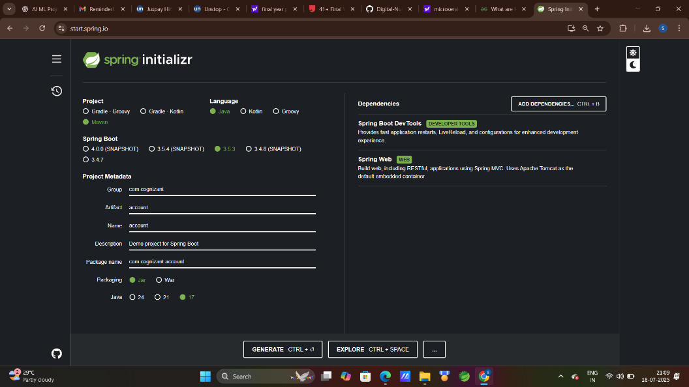

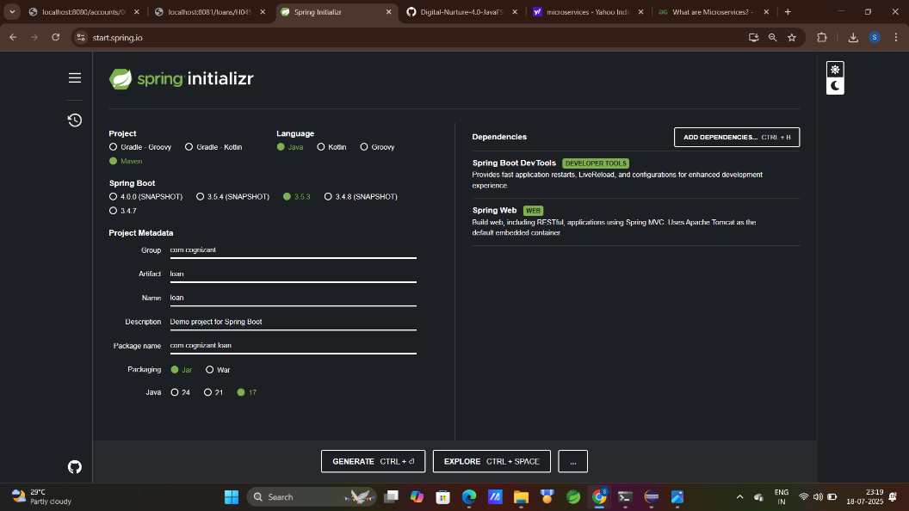

Each service should:

* Have its own @RestController.
* Run on a different port.(account ->port 8080, loan ->8081)

**Coding:**

i)Project : account

package com.cognizant.account.controller;

import java.util.HashMap;

import java.util.Map;

import org.springframework.web.bind.annotation.GetMapping;

import org.springframework.web.bind.annotation.PathVariable;

import org.springframework.web.bind.annotation.RequestMapping;

import org.springframework.web.bind.annotation.RestController;

*@RestController*

*@RequestMapping*("/accounts")

public class AccountController {

*@GetMapping*("/{number}")

public Map<String, Object> getAccount(*@PathVariable* String number) {

Map<String, Object> account = new HashMap<>();

account.put("number", number);

account.put("type", "savings");

account.put("balance", 344763);

return account;

}

}

spring.application.name=account

server.port=8080

package com.cognizant.account;

import org.springframework.boot.SpringApplication;

import org.springframework.boot.autoconfigure.SpringBootApplication;

*@SpringBootApplication*

public class AccountApplication {

public static void main(String[] args) {

SpringApplication.*run*(AccountApplication.class, args);

}

}

ii) Project: loan

package com.cognizant.loan.controller;

import java.util.HashMap;

import java.util.Map;

import org.springframework.web.bind.annotation.GetMapping;

import org.springframework.web.bind.annotation.PathVariable;

import org.springframework.web.bind.annotation.RequestMapping;

import org.springframework.web.bind.annotation.RestController;

*@RestController*

*@RequestMapping*("/loans")

public class LoanController {

*@GetMapping*("/{number}")

public Map<String, Object> getLoan(*@PathVariable* String number) {

Map<String, Object> loan = new HashMap<>();

loan.put("number", number);

loan.put("type", "gold");

loan.put("loan", 125000);

loan.put("emi", 2560);

loan.put("tenure", 8);

return loan;

}

}

spring.application.name=loan

server.port=8081

package com.cognizant.loan;

import org.springframework.boot.SpringApplication;

import org.springframework.boot.autoconfigure.SpringBootApplication;

*@SpringBootApplication*

public class LoanApplication {

public static void main(String[] args) {

SpringApplication.*run*(LoanApplication.class, args);

}

}

**File Structure:**

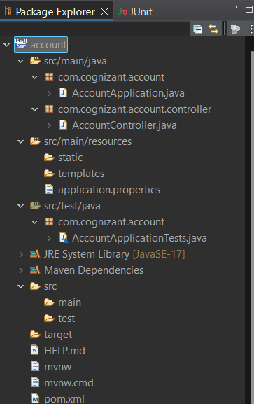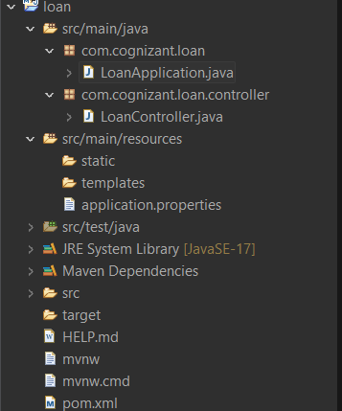

**Output:**

